02 | Neon Retro Rave Kandi Bundle | Festival Bead Charms
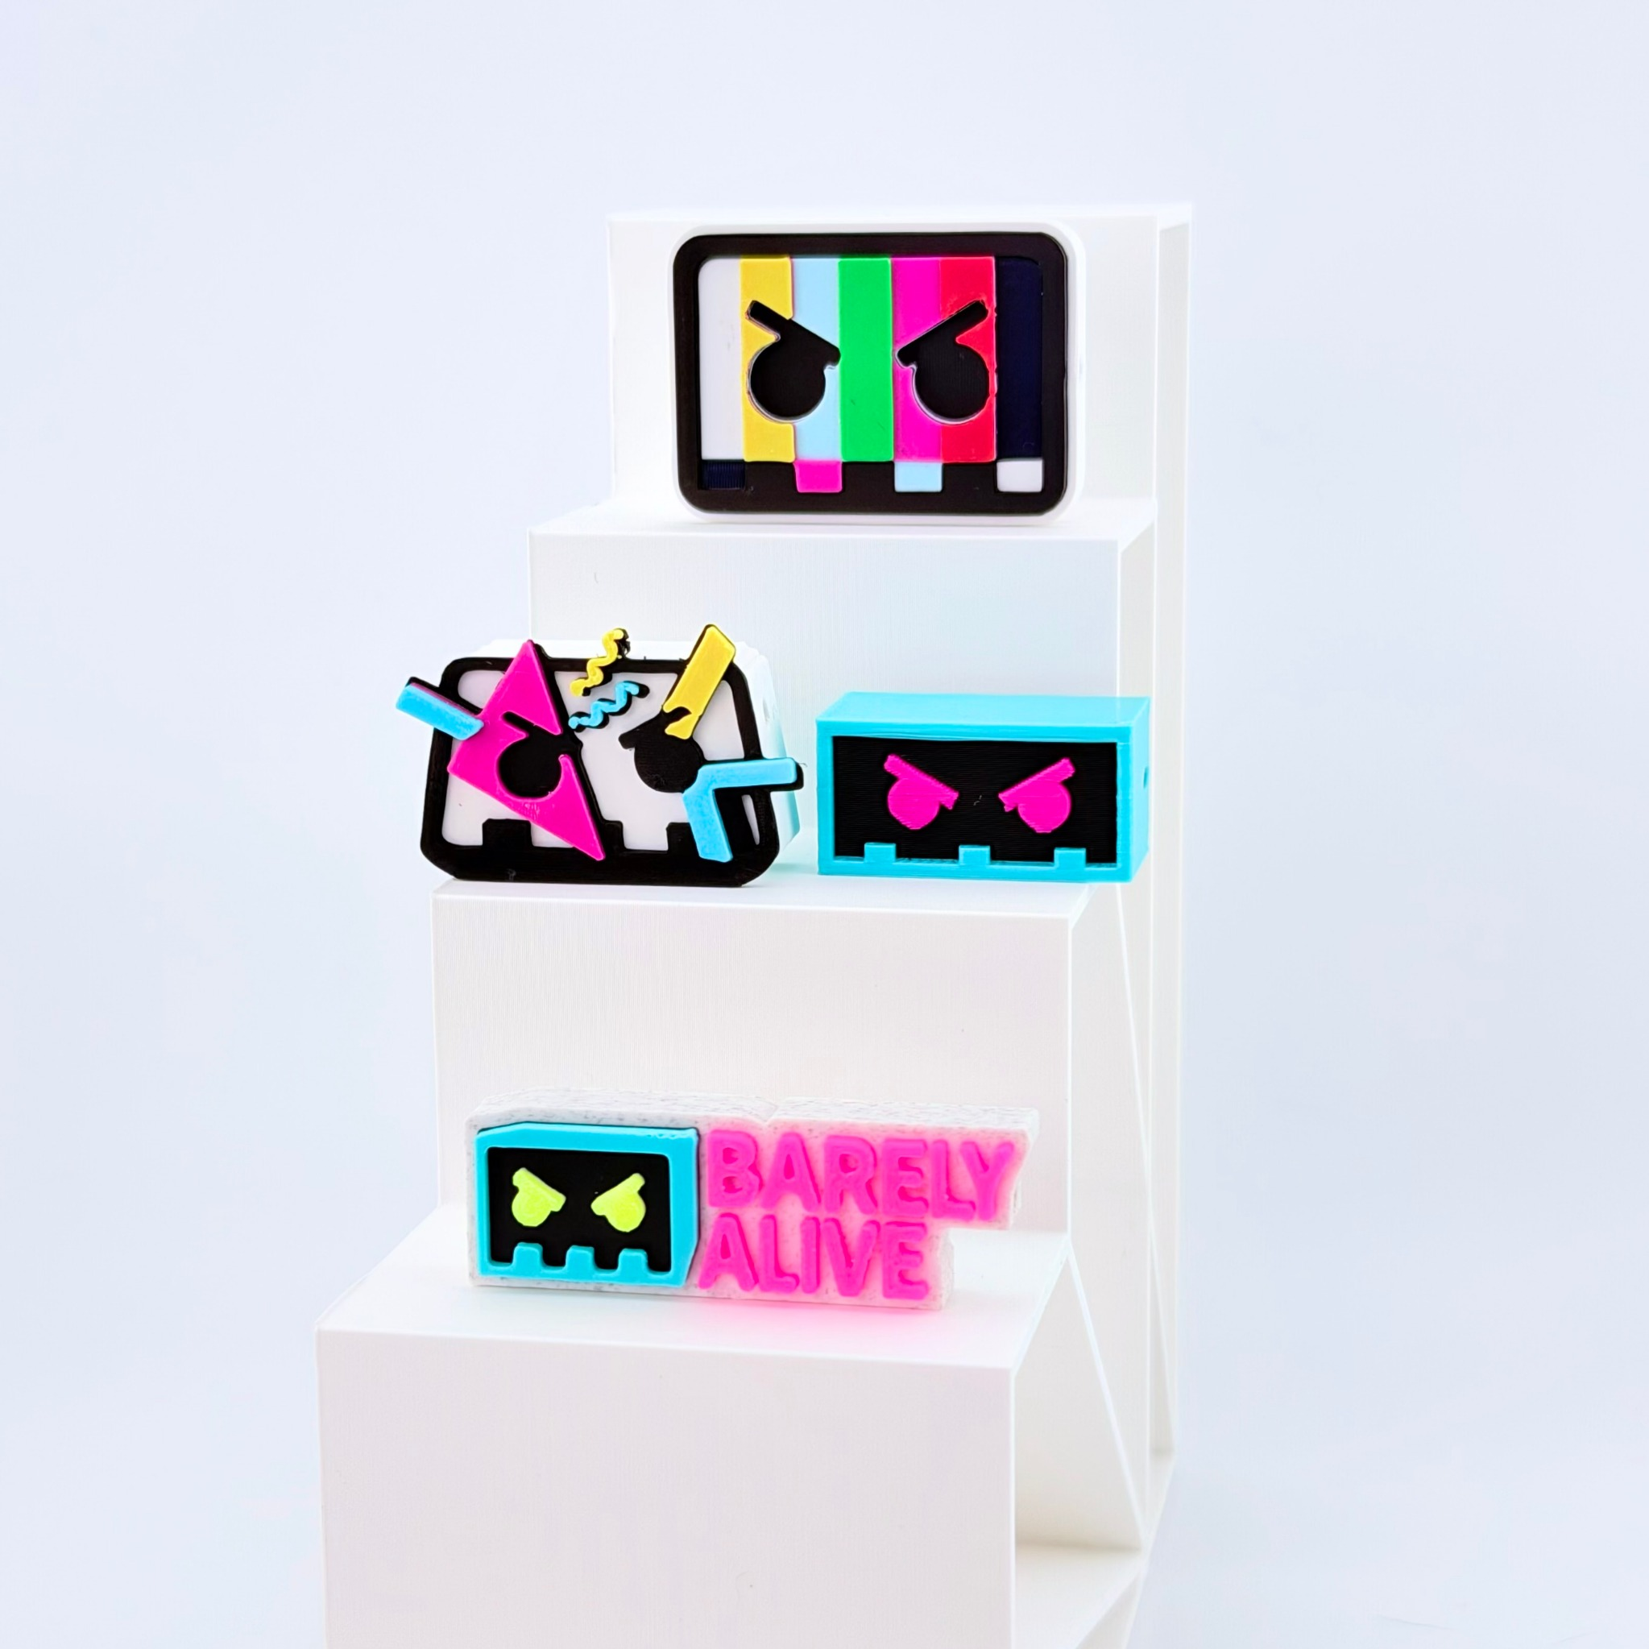
3D-printed PLA bead charms with built-in threading holes. Photo shows four design examples; no clips or springs.

Keyword Strategy
Primary: rave kandi charms
Secondary: 3D printed kandi beads, kandi bracelet charms, festival jewelry supplies, rave bead charms, EDM kandi accessories
Keywords are relevance-based recommendations; search volumes were not independently verified.

Shopify
Product title: Neon Arcade Rave Kandi Charms | 3D Printed Beads
Bring retro arcade energy to your next kandi creation with these colorful 3D-printed bead charms! Featuring vibrant neon colors, pixel-inspired graphics, and bold geometric designs, these lightweight PLA charms add a playful touch to kandi bracelets, necklaces, and festival accessories. Each charm includes a built-in bead hole for threading onto kandi string or incorporating into custom jewelry projects. Whether you’re creating new pieces for your collection, trading kandi with your rave crew, or putting together festival gifts, these neon-inspired designs are ready to join your next creation.
- Neon Arcade Designs: Colorful pixel-style graphics and bold geometric details.
- Lightweight PLA: 3D-printed plastic charms for kandi making.
- Built-In Bead Hole: Designed for bracelets, necklaces, and crafts.
- Resealable Packaging: Charms packaged together in a protective resealable bag.
SEO page title: Neon Arcade Kandi Charms | Rave Bead Bundle
Meta description: Shop neon arcade rave kandi charm bundle. Lightweight 3D-printed beads for festival bracelets, necklaces, and custom kandi jewelry.

Etsy
Product title: Neon Arcade Rave Kandi Charms, 3D Printed Kandi Beads for Festival Bracelets, EDM Jewelry Making Supplies
Add a splash of neon nostalgia to your kandi creations! These colorful 3D-printed rave kandi charms feature retro arcade-inspired graphics, bright pixel-style designs, and playful geometric details. Made from lightweight PLA plastic, each charm features a built-in bead hole for creating kandi bracelets, necklaces, and personalized festival jewelry. Mix them with your favorite pony beads, create one-of-a-kind PLUR bracelets, or add them to your next kandi trading collection. Materials: PLA plastic. Pack quantity and design mix should be confirmed for each variation.
- Arcade-Inspired Designs: Vibrant neon colors and pixel-style graphics.
- 3D-Printed PLA: Lightweight decorative bead charms.
- Built-In Bead Hole: For threading onto kandi bracelets, necklaces, and crafts.
- Resealable Bag: Charms packaged together for convenient storage.
13 Etsy tags: rave kandi charms, kandi beads, 3d printed beads, festival beads, edm kandi, neon kandi charms, bracelet charms, jewelry making, plur trading beads, focal beads, pony bead charm, diy kandi, craft supplies
Recommended category: Craft Supplies & Tools > Beads > Plastic Beads (confirm available path)

TikTok Shop
Product title: Neon Arcade Rave Kandi Charms, 3D Printed Beads for Bracelets & Festival Jewelry
Give your kandi creations a neon arcade upgrade! These colorful 3D-printed rave kandi charms feature bold pixel-inspired designs and vibrant geometric details. Made from lightweight PLA plastic, each charm includes a built-in bead hole for adding to bracelets, necklaces, and custom festival jewelry. Mix, create, and trade with your rave crew!
- Neon Arcade Designs: Bright colors and retro pixel-inspired graphics.
- Lightweight PLA: 3D-printed decorative bead charms.
- Built-In Bead Hole: Designed for kandi bracelets and necklaces.
- Creative Versatility: Add to custom jewelry, festival accessories, and kandi crafts.
- Resealable Packaging: Charms packaged together in a protective bag.
Recommended category: Jewelry Making Supplies / Beads & Jewelry Findings (confirm in Seller Center)

